MINI PROJECT SYNOPSIS
DISEASE PREDICTOR
SUBMITTED FOR THE PARTIAL FULFILLMENT OF
THE B.TECH.(BRANCH)SECOND YEAR III SEMESTER COURSE
MINI PROJECT- BCC 351
AT
DRONACHARYA GROUP OF INSTITUTIONS

BY
1. NAME: MAHIMA SHARMA AND ROLL NUMBER: 2402301530040
2. NAME: JASMEEN KAUR AND ROLL NUMBER: 2402301530034
3. NAME: LAVI SHARMA AND ROLL NUMBER: 2402301530039
Affiliated to

Dr. A P J ABDUL KALAM TECHNICAL UNIVERSITY, LUCKNOW
ACADEMIC SESSION 2025-26 (ODD)

TOPIC: DISEASE PREDICTION

Introduction
Healthcare is facing significant challenges due to the rising prevalence of chronic diseases and limited availability of medical professionals to handle vast patient data. Traditional diagnostic approaches are often time-consuming and may involve inaccuracies due to human limitations. By leveraging Artificial Intelligence (AI) and Machine Learning (ML), it becomes possible to develop robust disease prediction systems capable of analyzing patterns in patient data for early and precise diagnosis, which can reduce risks and improve health outcomes.

Problem Statement
The lack of timely diagnosis and limited access to expert doctors lead to delayed treatment, increasing mortality and healthcare costs. Manual disease prediction methods are prone to human error and cannot process large-scale patient data effectively. Therefore, there is a need for an automated, intelligent, and accurate disease prediction system that can support doctors and empower patients with early insights into their health condition.

Objective
- To design an AI/ML-based model for accurate prediction of diseases.
- To preprocess and analyze medical datasets for extracting meaningful features.
- To compare different ML algorithms (e.g., Logistic Regression, Random Forest, SVM, Neural Networks) to identify the most efficient model.

About the Project
Scope:
- The system can be trained for multiple diseases (e.g., diabetes, heart disease, cancer risk).
- It can assist healthcare professionals as a decision-support tool.
- The project can be extended to continuous monitoring through wearable devices and integration with Electronic Health Records (EHRs).
- Prediction output can be adapted for both clinical use (for experts) and patient-friendly reports (for public use).

Requirements:

Hardware Requirements:

- Processor: Intel i3 or higher
- RAM: Minimum 4 GB
- Storage: 250 GB HDD / 128 GB SSD
- Webcam (for gesture capture)

Software Requirements:
- Operating System: Windows 10 / Linux
- Language: Python
- Libraries: OpenCV, TensorFlow/ Keras, NumPy
- Tools: Jupyter Notebook / VS Code, Git & GitHub

System Requirements:
- Python run time environment.
- NPM Installed dependencies via pip (OpenCV,TensorFlows/Keras,etc.)
- Webcam access

Methodology:
- Data Collection: Open-source datasets or healthcare-provided anonymized datasets
- Data Preprocessing: Cleaning, normalizing, handling missing values, and feature selection.
- Model Training: Implementation of ML algorithms like Decision Trees, Random Forest, Logistic Regression, or Neural Networks.
- Evaluation: Testing models using accuracy, precision, recall, F1 score, and ROC-AUC.
- Deployment: Building a simple application/GUI/web interface for user interaction

Project Flow Chart:

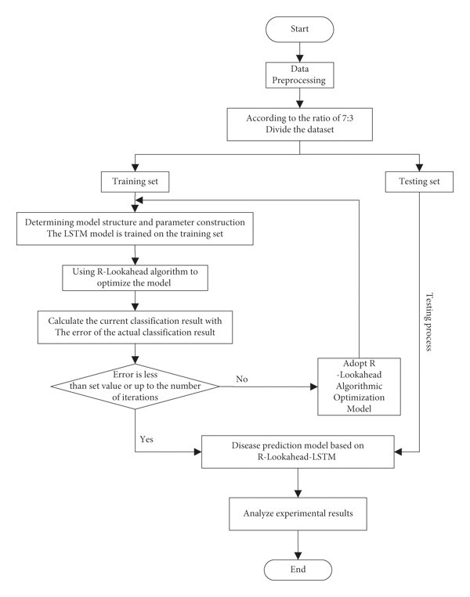

Gantt Chart:
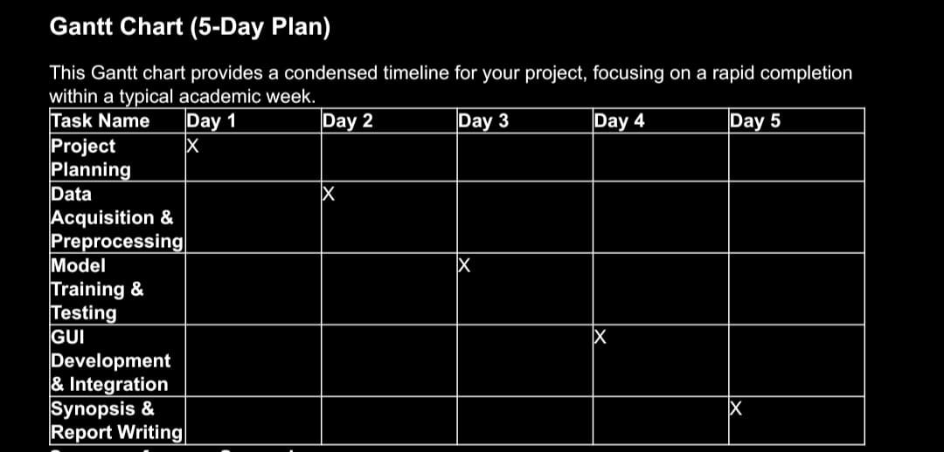

References
- "Disease Prediction Synopsis" - Scribd
- "Heart Disease Prediction using ML Abstract" - IJCRT.org
- "Disease Prediction Using Machine Learning Project Ideas" - PhDProjects.org
- OpenCV Official Documentation
- "Symptoms Based Disease Prediction Using Machine Learning Techniques" - IJSET.in
- "How to write a research synopsis with examples" - YouTube
- Research papers on Sign Language Recognition

Expected Outcomes
- A reliable disease prediction model with high accuracy
- Reduction of diagnostic delay and better decision support for doctors.
- Scalable system adaptable for multiple diseases and larger datasets.
- Contribution toward preventive healthcare and early risk detection.

Team Members:

S. No. | Name | Branch | University Roll No. | College Roll No. | Signature
1. | Mahima Sharma | CSE AI&ML | 2402301530040 | 19514
2. | Jasmeen Kaur | CSE AI&ML | 2402301530034 | 19507
3. | Lavi Sharma | CSE  AI&ML | 2402301530039 | 19513

